Voltage And Current Quiz
28Jul24 B.R.

Quiz Instructions
Numerical answers must be just the number, in the specified units. E.g., if the answer is 3.2 volts, then the answer (in volts) should be just 3.2, and the answer (in mV) is 3200.

Question 1
A 1k resistor is connected to a Thevenin voltage source characterized with Vth = 10V and Rth = 1 Ohm. The current (in mA) is:

Question 2
A 1k resistor is connected to a Thevenin voltage source characterized with Vth = 10V and Rth = 1 Ohm. The voltage across the 1k resistor is (in V)

Question 3
A 1k resistor is connected to a Thevenin voltage source characterized with Vth = 10V and Rth = 1 Ohm. The power dissipated by the 1k resistor is (in mW)

Question 4
A 1k resistor is connected to a Thevenin voltage source characterized with Vth = 10V and Rth = 1 Ohm. The power dissipated by Rth is (in mW)

Question 5
A 1k resistor is connected to a Thevenin voltage source characterized with Vth = 10V and Rth = 1 Ohm. The Thevenin voltage source acts more like
- a constant voltage source
- a constant current source
- a constant power source
- none of the above

Question 6
In Figure 5 of Voltage and Current, the downward asymptotes indicate the y and x axis are related to each other as:
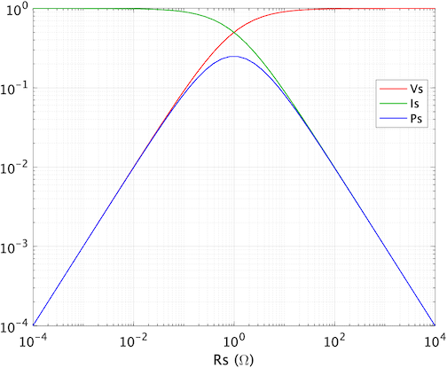
- y = m*x + b, where m is a slope
- y = a * log(x), with a = constant
- y = a * exp(-b*x) with a and b = constants
- y = (x+a)^b with a and b = constant

Question 7
Consider our now familiar Thevenin voltage source characterized with Vth = 10V and Rth = 1 Ohm is far from a load, RL =20 ohm, and the wires between them have 10 ohms of resistance. The power dissipated by RL is (in W)
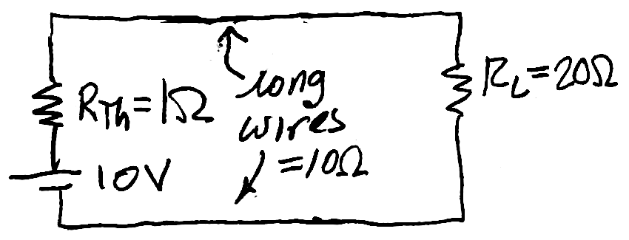

Question 8
To achieve maximum power transfer to RL in the previous question, RL should have a value (in Ohms) of:

Question 9
You can answer the next question in numerous ways using MATLAB's help system. We used MATLAB's logspace() function in this unit, and MATLAB also has a linspace() function. Which of the following statements are false?
- linspace(x1,x2) and logspace(log10(x1),log10(x2)) have the same domains.
- length(linspace(x1,x2)) == length(logspace(x1,x2))
- both return row vectors, which can be "transposed" into column vectors with the ' operator
- the colon operator, :, can be used in place of linspace

Question 10
We set the 'location' of the legend to 'best', so MATLAB would't cover data with the legend box (see >> doc legend). To put the legend outside the plot, e.g., to the right of it, we would have specified 'location',
- 'right'
- 'rightoutside'
- 'eastoutside'
- 'outsideright'

Answers:
- I = Vth / 1k = 1mA, ignore Rth <<< 1k.
- V = 10V, again ignore Rth <<< 1k
- P = 10V * 1mA = 10mW
- P = i^2Rth = (1e-3A)^2*1ohm = 1uA = .001mA, note its 1/1000 the previous answer confirming ignoring it in earlier problems is ok – it’s effect is small vs. the dominant R
- A
- D
- Draw the circuit first. Rseries = 1+10+20Ω = 31Ω, I = 10V/31Ω and P I^2RL= 2.08W
- 11 Ω
- B
- C

